**User Manual**

**Lunar**

Hanbin Baik (hanbin.baik@stonybrook.edu)

Hyejun Jeong (hye-jun.jeong@stonybrook.edu)

Hanna Jung (hanna.jung@stonybrook.edu)

**Table of Contents**

1. GENERAL INFORMATION
   1. System Overview
   2. Organization of the Manual
2. SYSTEM SUMMARY
   1. System Configuration
   2. User Access Levels
   3. Contingencies
3. GETTING STARTED
   1. Login to the Account
   2. System Menu
      1. Home Button
      2. Add Button
      3. Edit Button
      4. Record Button for Admin
      5. Search Button
      6. Enroll Button
      7. Record Button for Students
      8. Drop Button
4. **GENERAL INFORATION**

In General Information section explains the system briefly and the purpose of the Lunar.

* 1. **System Overview**

Lunar is an educational database app that helps students to search, enroll, and drop the courses. Students can also view their current and history records. Lunar also allow admin to add students, professors, and courses. Admin can edit courses and view a student’s history record.

* 1. **Organization of the Manual**

The user’s manual consists of five sections: General Information, System Summary, Getting Started, and Using the System.

General Information section explains the purpose of this application and specific terms to make a user to understand this application easily.

Getting Started section explains how students and admin can log in to the page. This section also provides brief information about system menus: Search, Enroll, Record, and Drop for students and Add Courses, Add Students, Add Professors Edit Courses, and View Student Record.

1. **SYSTEM SUMMARY**

System Summary section explains an overview of the Lunar.

* 1. **System Configuration**

Lunar operates on computers that is connected to the internet and localhost. This database application requires an account to enroll, drop, and edit classes, and view one’s current and history records.

**2.2 User Access Levels**

Stony Brook students and admin can use Lunar. A user needs a computer connected to the Internet and localhost to log in to the application.

**2.3 Contingencies**

If a user’s computer is connected to the Internet and localhost, a user can use lunar at any time or under any condition. A student user can only schedule courses for him/her but cannot schedule courses for another student.

**3.0 GETTING STARTED**

Getting Started section explains how to use the Lunar. This section has brief information about the system menu.

**3.1 Log in to the Account**

The URL that user can access the front page of the web application is <http://localhost/lunar_v.5/index.html>. When a user first enters to the application, a user needs to log in to the student account or the admin account (Figure 1). If a user clicks ‘LOGIN AS ADMIN,’ a user can log in as admin (Figure 2). If a user clicks ‘LOGIN AS STUDENT,’ user can log in as a student (Figure 3). The examples below are the accounts that a user can log in to.

(E.g. student ID: 1, password: hanbin96)

(E.g. admin ID: 1, password: love305)

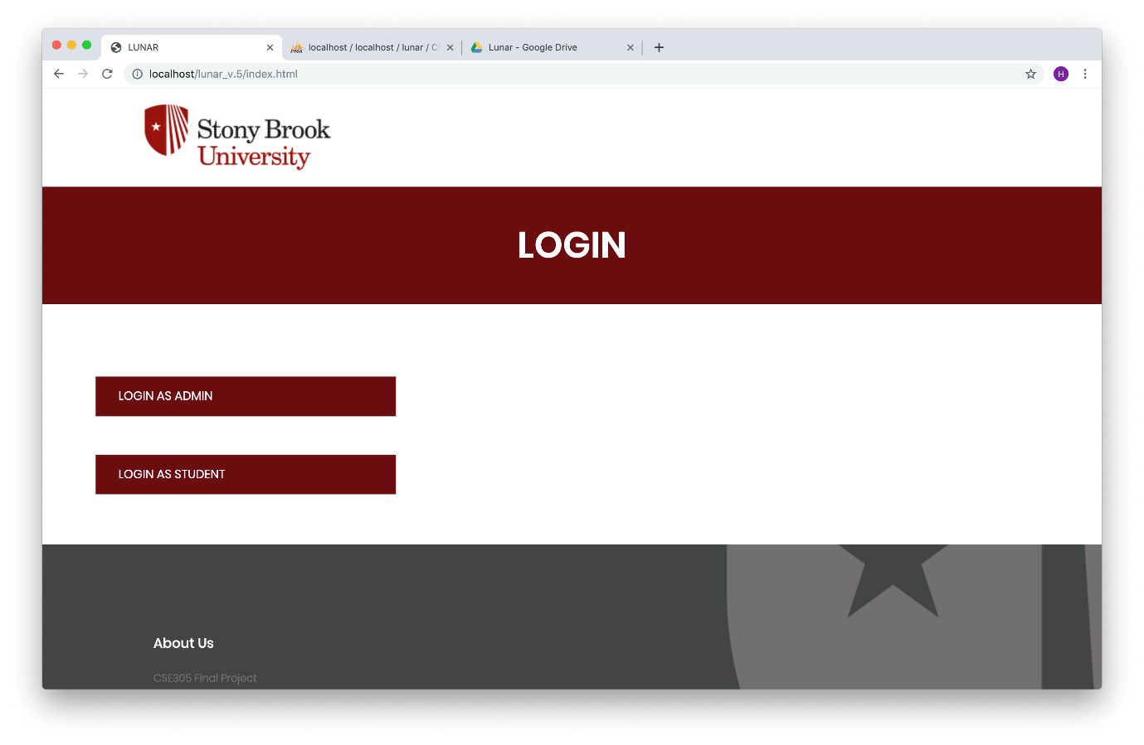

Figure 1. Homepage of Lunar

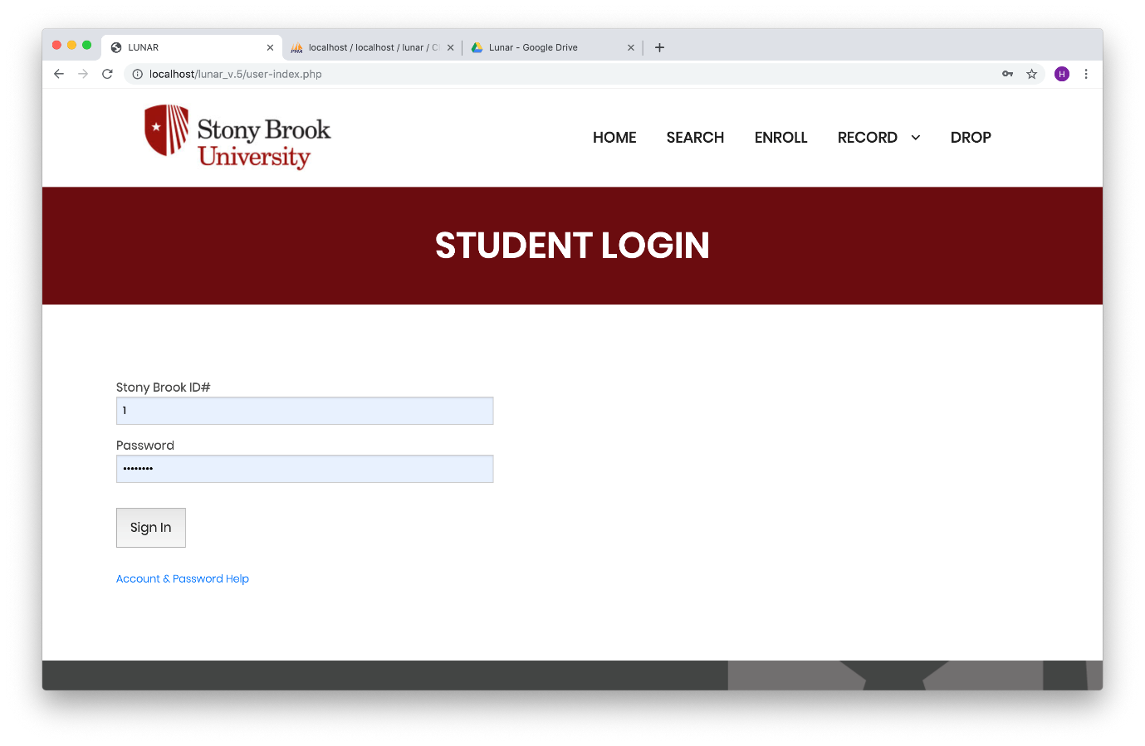

Figure 2. Student Login Page

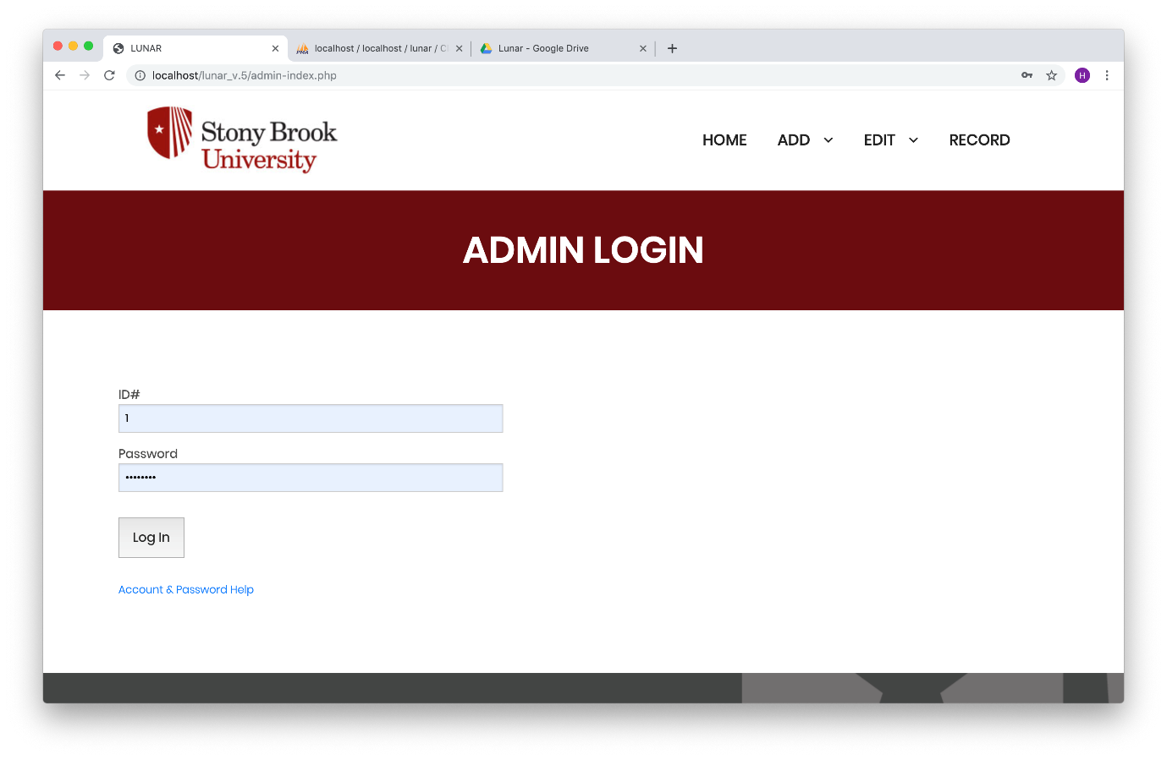

Figure 3. Admin Login Page

When a student successfully logs in to the account, the Welcome page for student is displayed (Figure 4). When an admin successfully logs into the account, the Welcome page for admin is displayed (Figure 5).

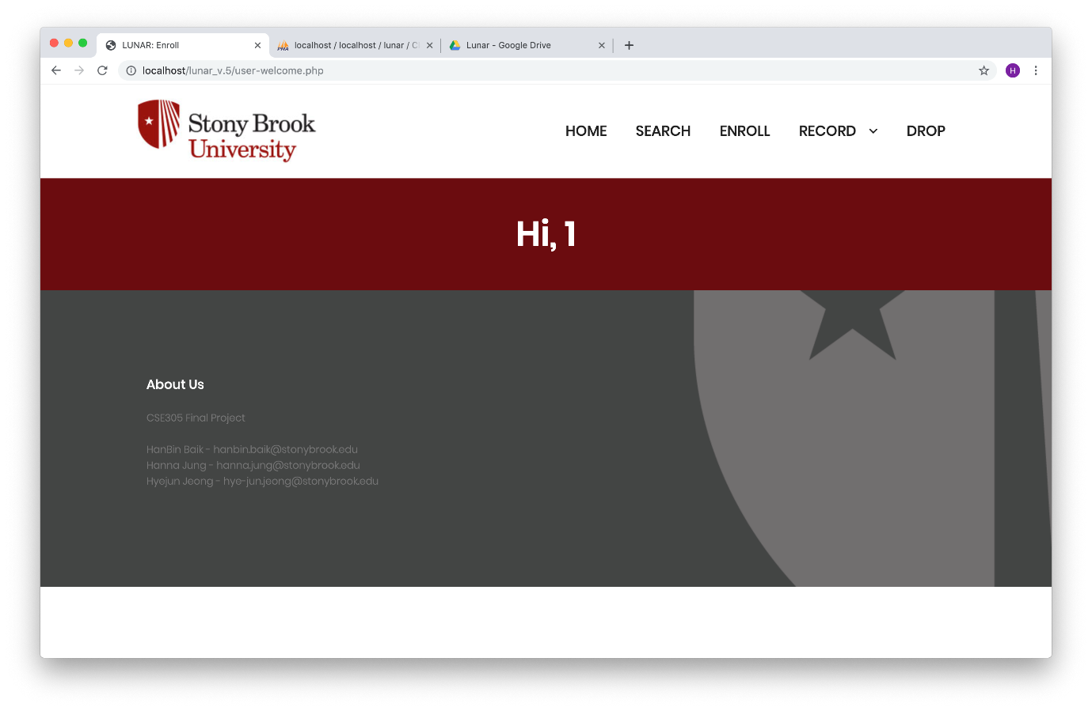

Figure 4. Student Welcome Page

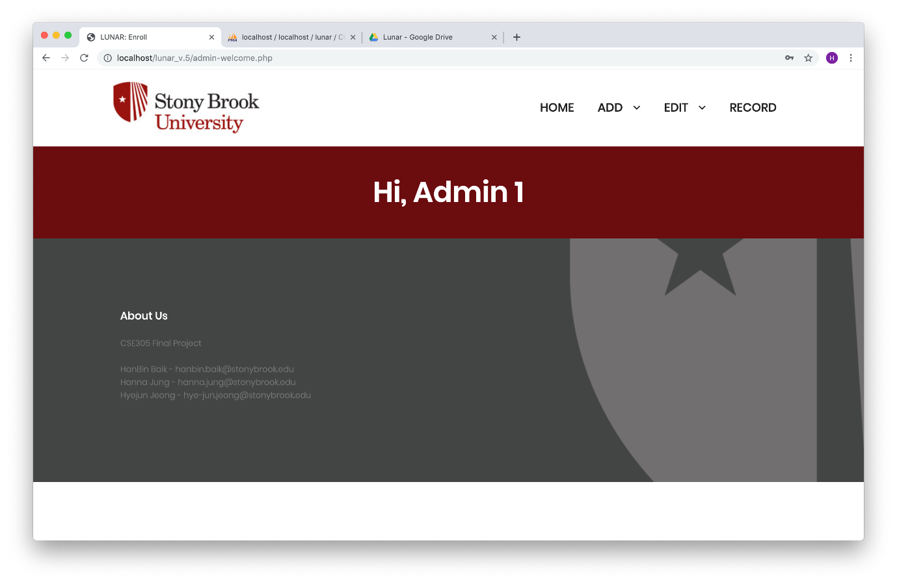

Figure 5. Admin Welcome Page

If a user fails to log in to an account, the phrase ‘Login Failed!’ will be displayed. The picture below is the one that appears when the student fails to log in (Figure 6).

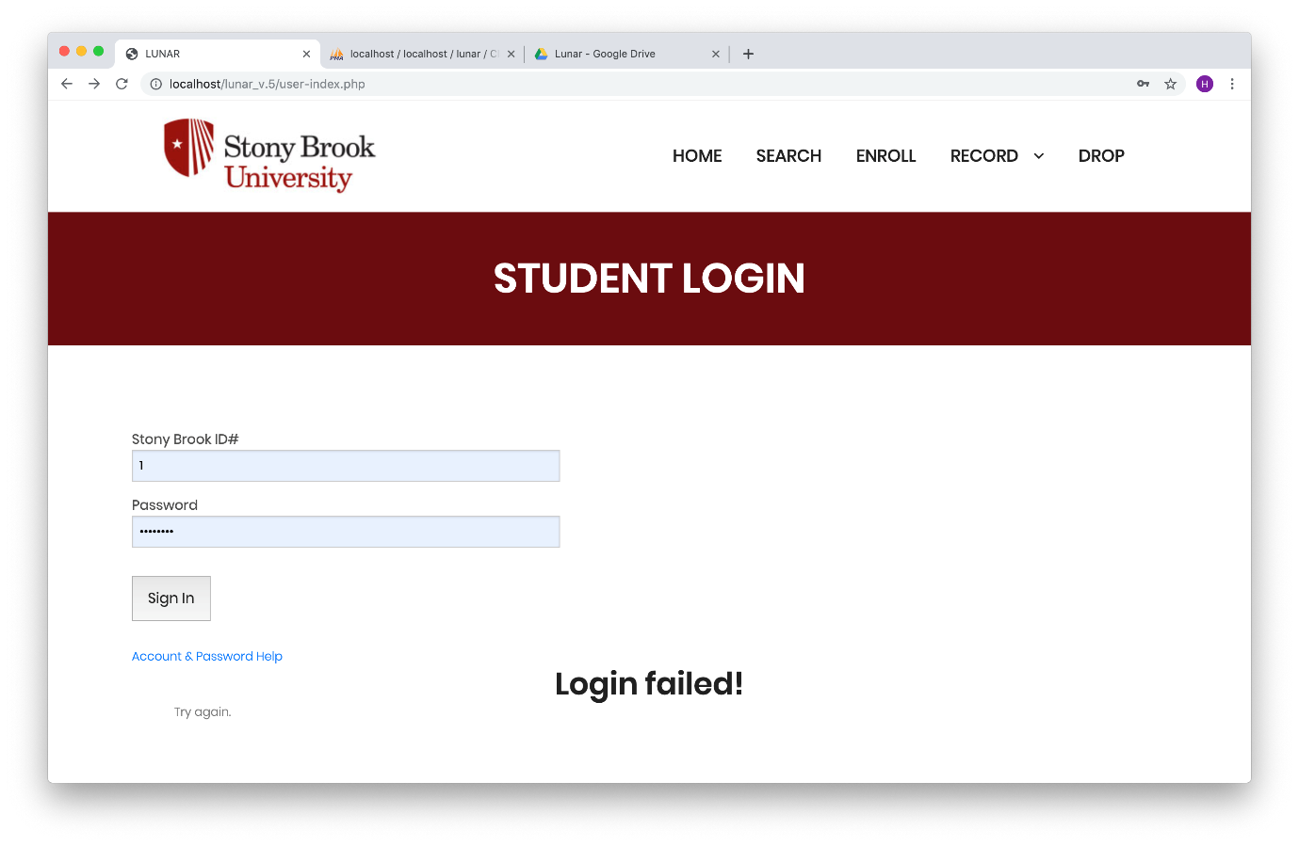

Figure 6. Login Failed Page

**3.2 System Menu**

Lunar is an application, which consists of 2 panes. Top pane has system menus and bottom pane has each page’s contents. There are 5 buttons on the top pane in student page (Figure 7). There are Home, Search, Enroll, Record, and Drop. There are 4 buttons on the top pane in admin page (Figure 8). There are Home, Add, Edit, and Record.



Figure 7. System Menus in Admin Page



Figure 8. System Menus in Student Page

**3.2.1 Home Button**

A user can click this button to go to the main home page. The Stony Brook University logo also can lead users to the main home page.



Figure 9. Main Home Page

**3.2.2 Add Button**

Admin can click this button to add students, professor, and courses. Admin can add student by giving type of student, student first name, student last name, major, and minor (Figure 10). Figure 11 shows an example of adding an undergraduate student with a first name of File and a last name of Management.

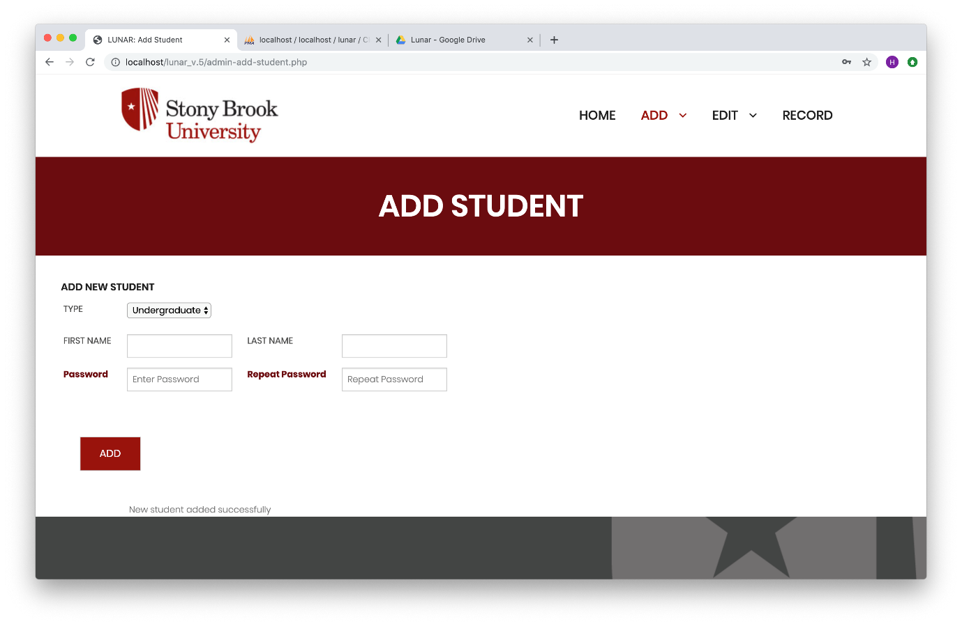

Figure 10. Add Student Page

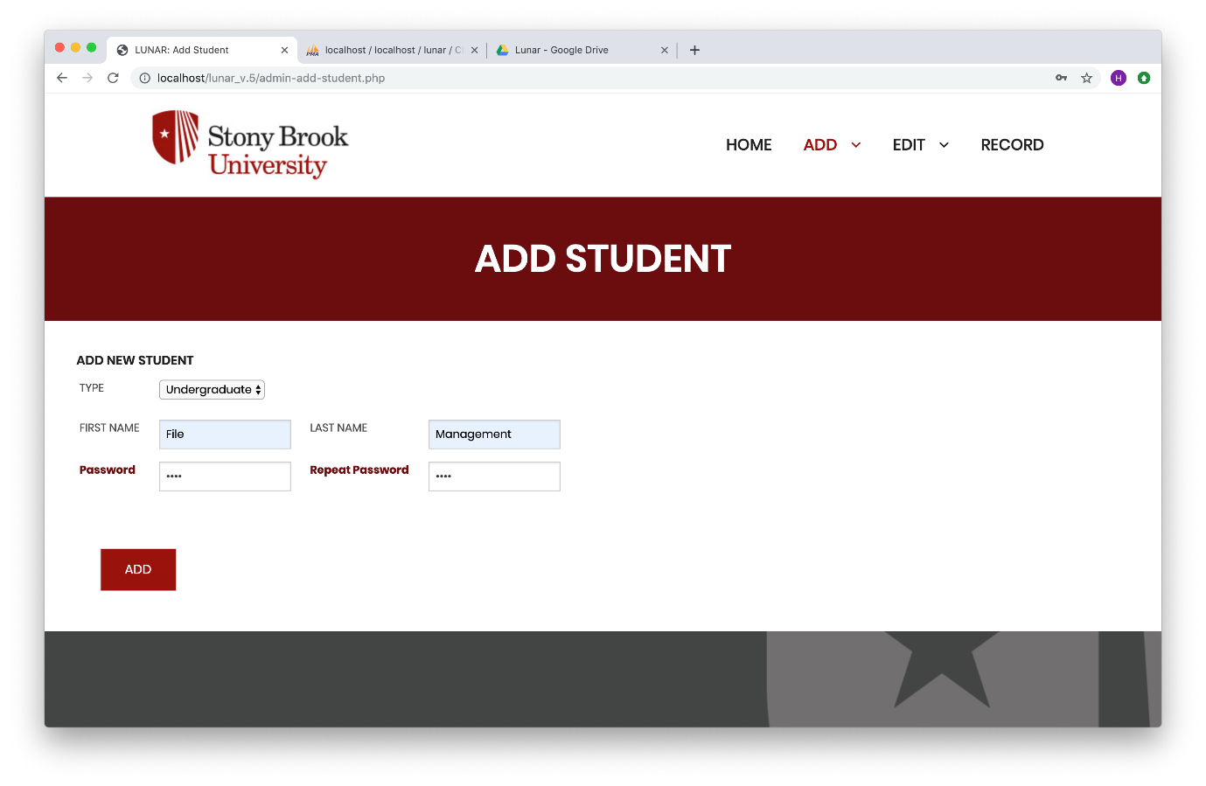

Figure 12. Add Student Page Example

Admin can add new professors by giving first name, last name and department (Figure 12). Figure 13 shows an example of adding a CSE professor with a first name of Operating and a last name of System.

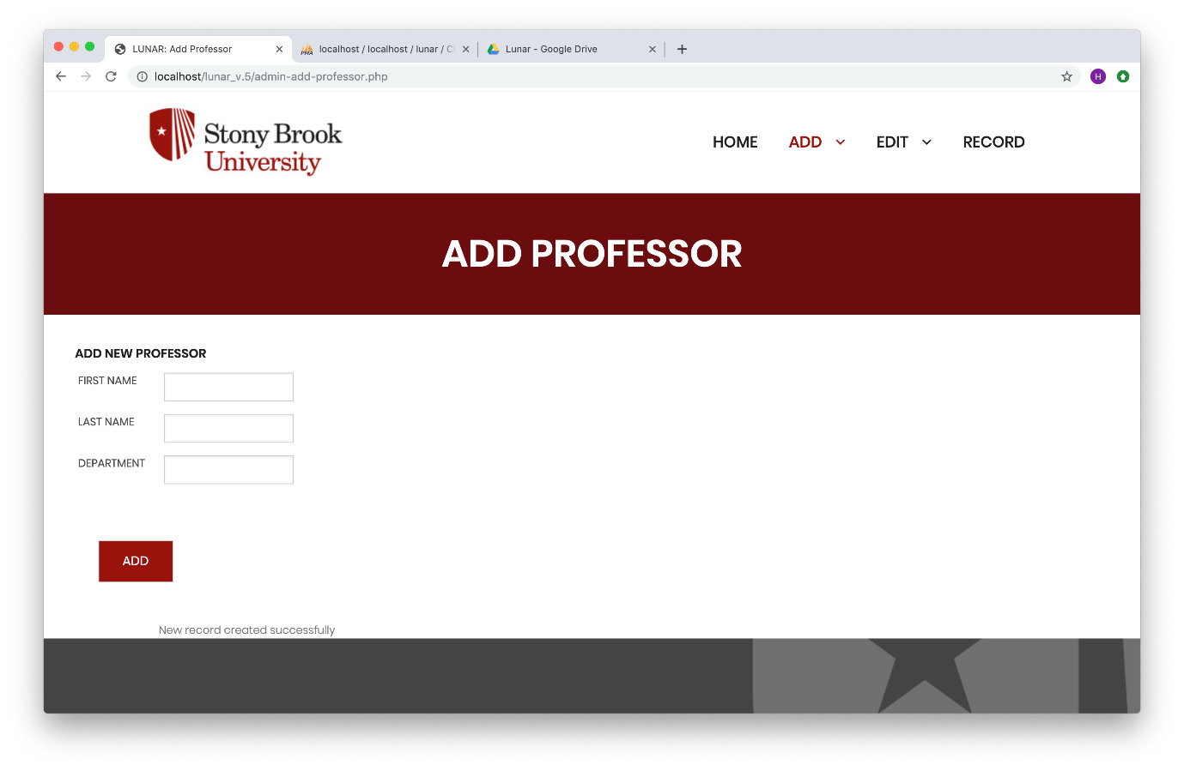

Figure 12. Add Professor Page

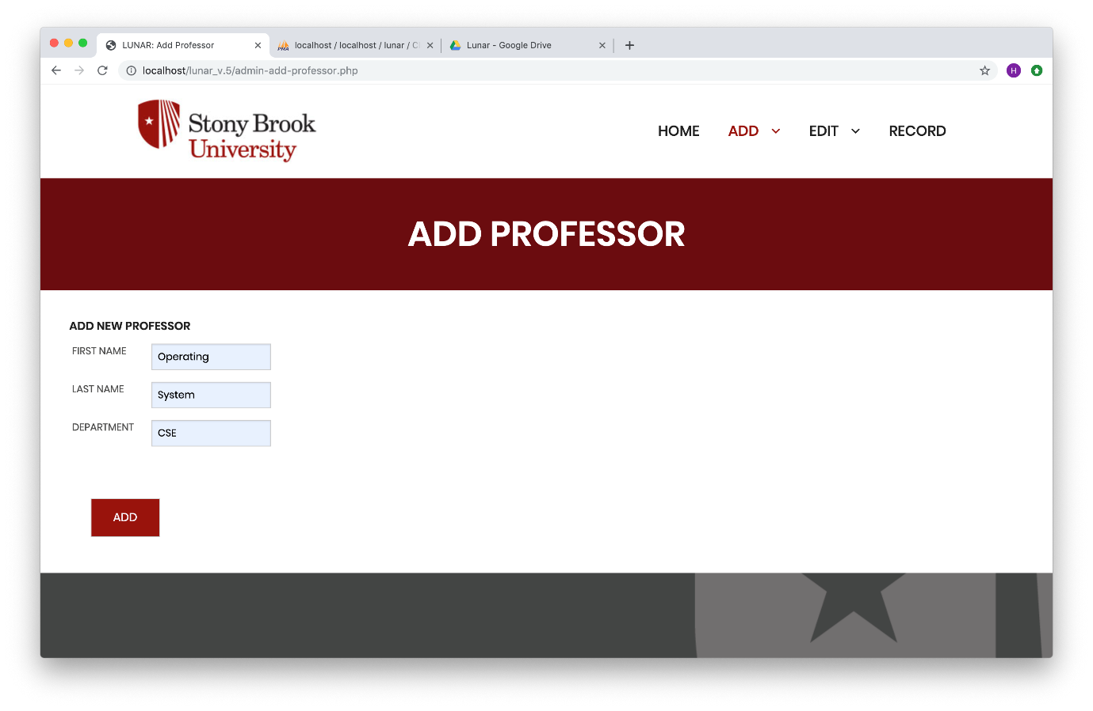

Figure 13. Add Professor Page Example

Admin can add a course by giving a course id, credit, subject, course number, cmp (LEC/REC/LAB), section, title, start time, end time, room, capacity, professor, semester, days, SBC requirements (Figure 14). Figure 15 shows an example.

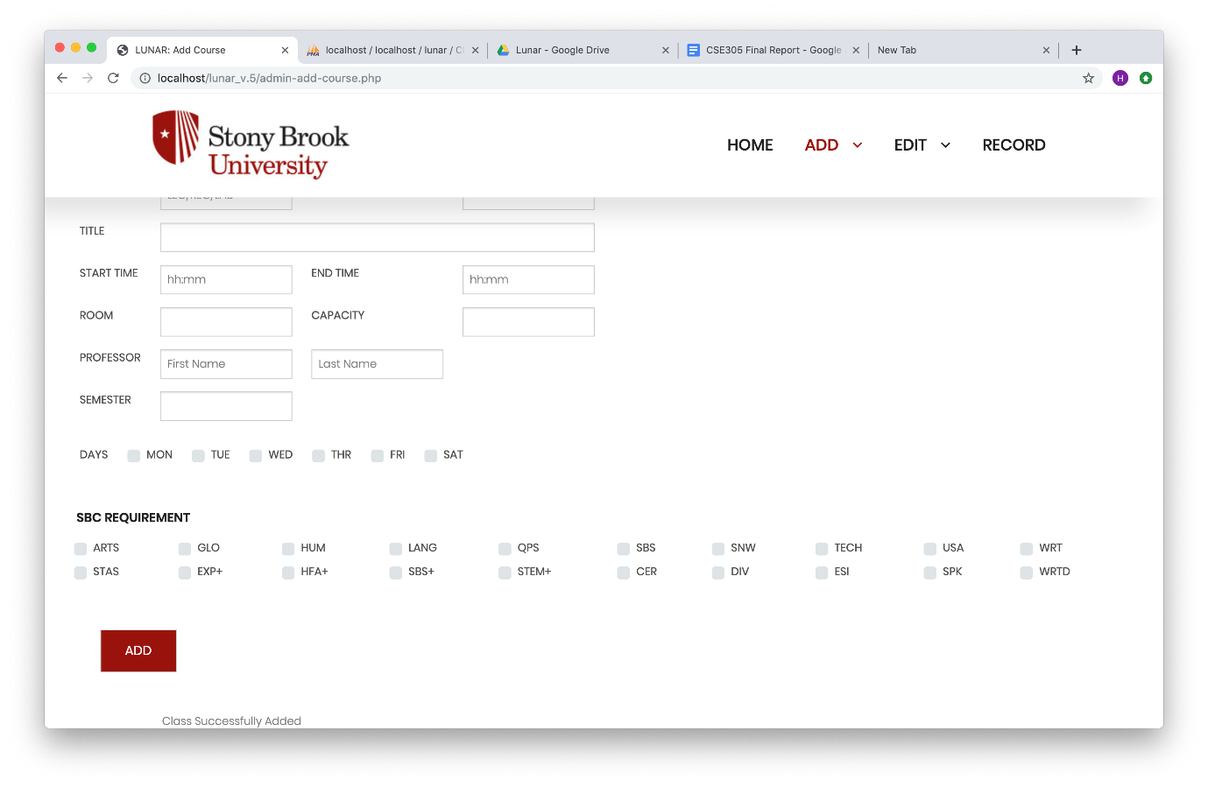

Figure 14. Add Course Page

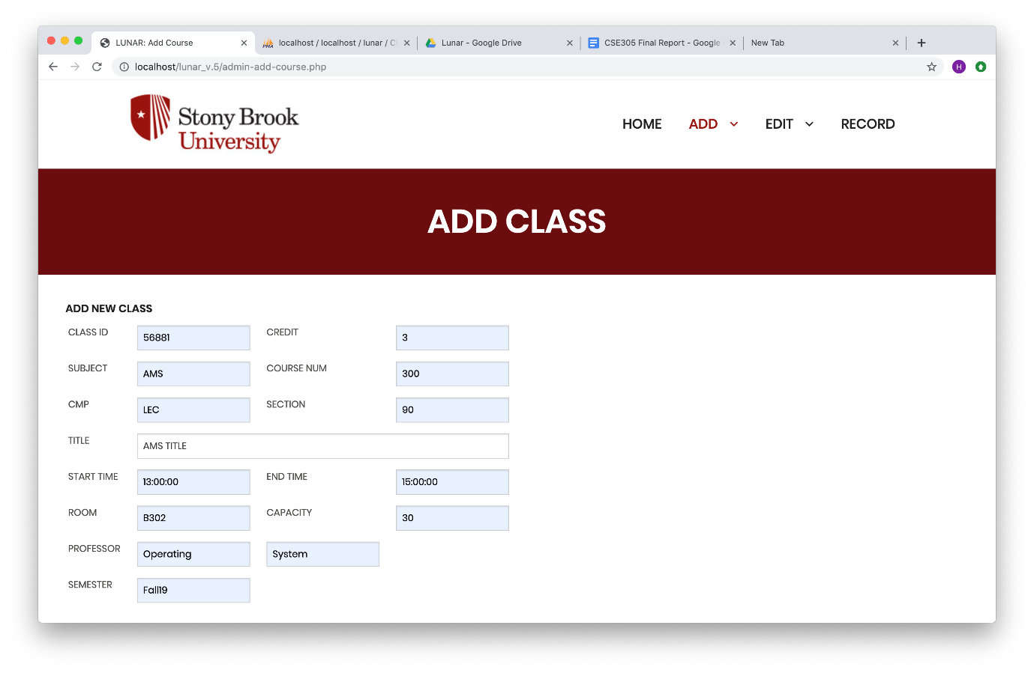

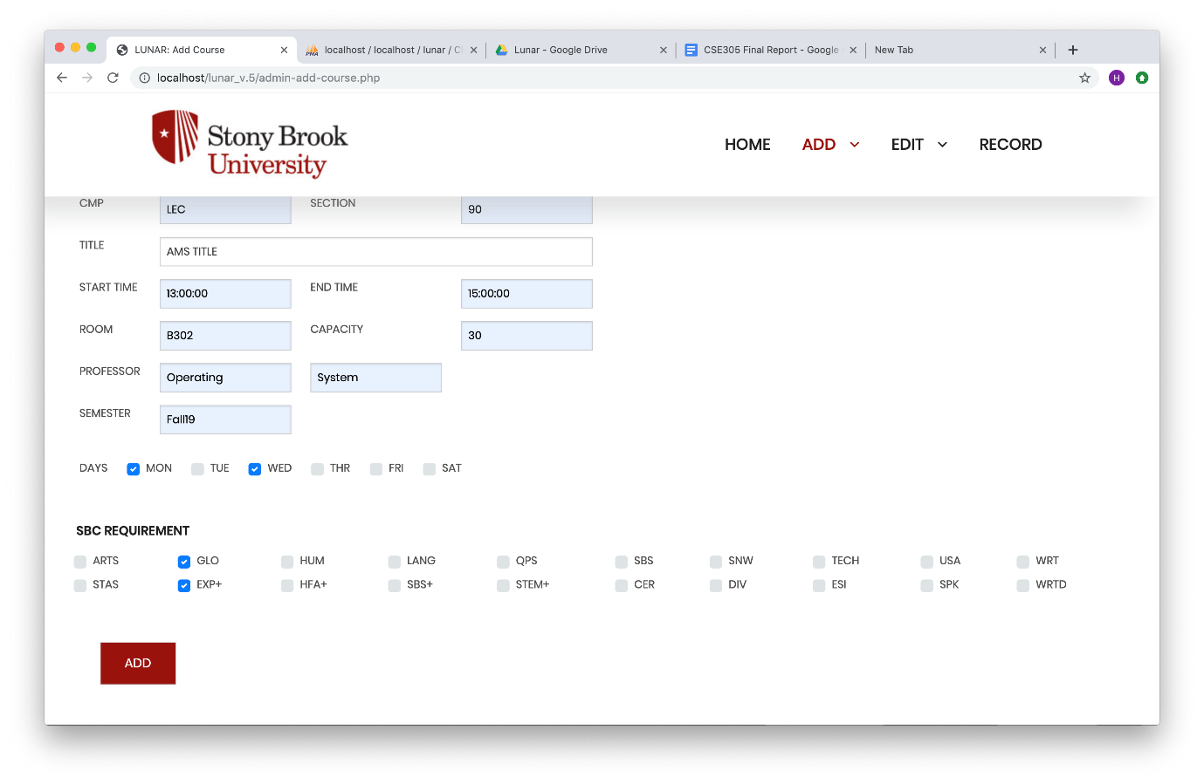

Figure 15. Add Course Page Example

**3.2.3 Edit Button**

Admin can click this button to edit the desired course by entering the ID number of the course (Figure 16). Admin can edit a course by giving a course id, credit, subject, course number, title, days, start time, end time, room, capacity, professor, and SBC requirements. Figure 17 shows an example of editing a course.

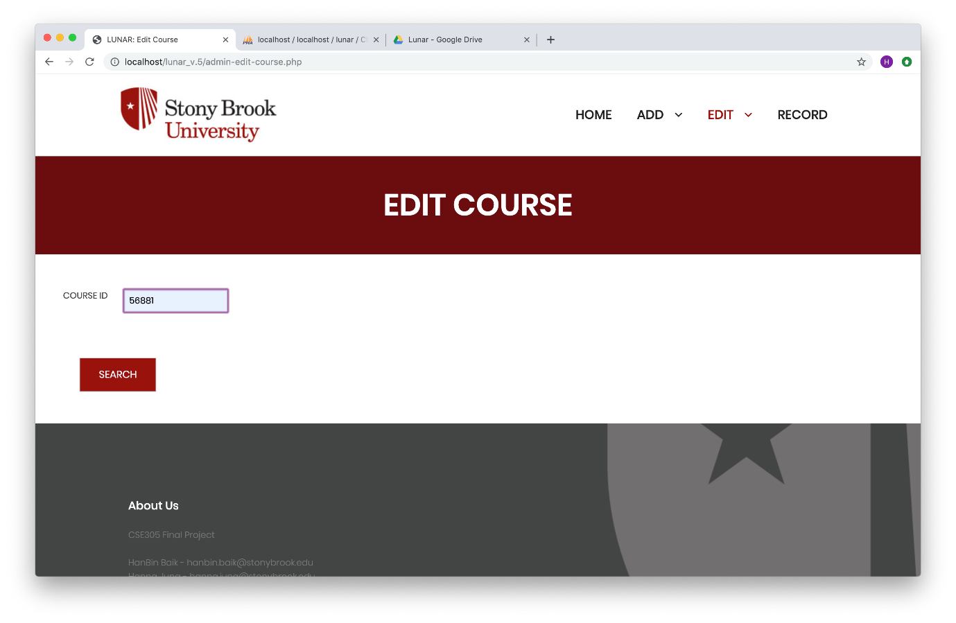

Figure 16. Enter a Course ID Number to Edit Course

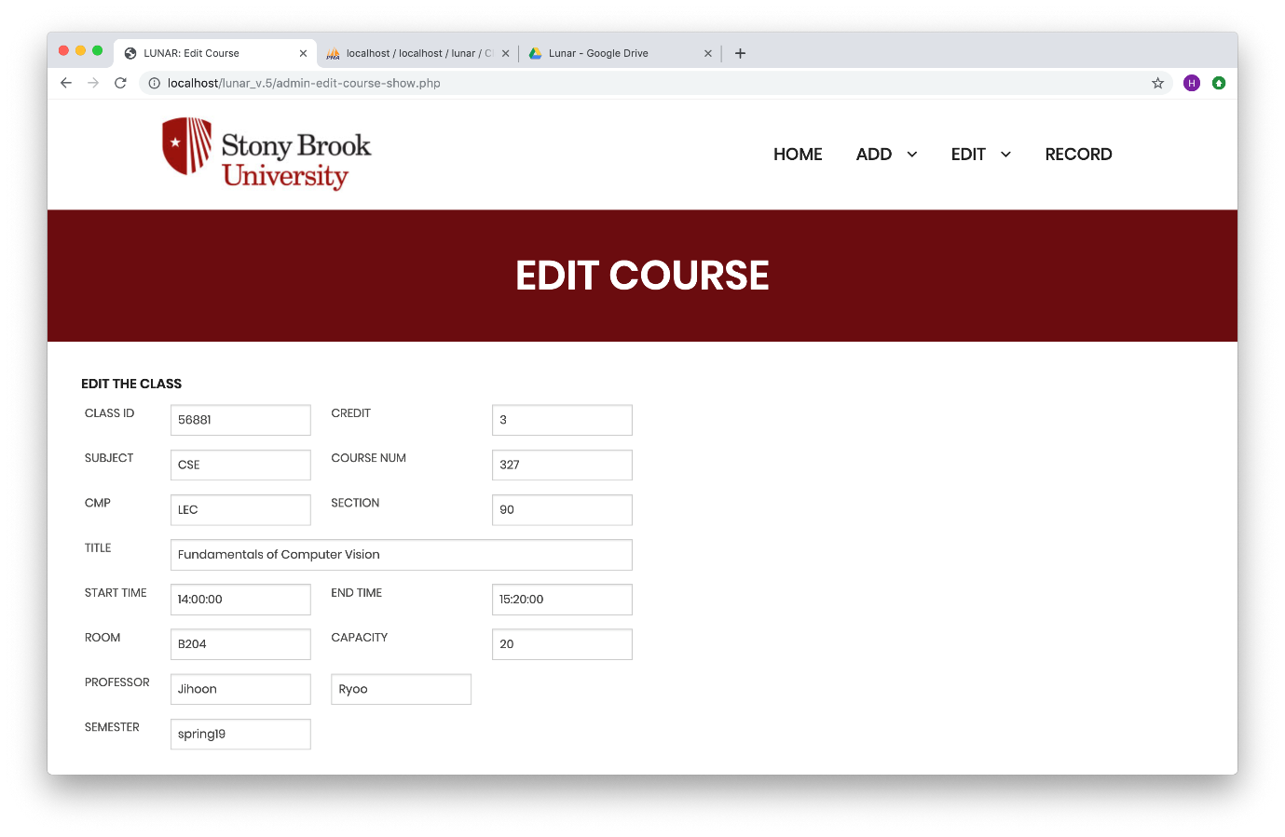

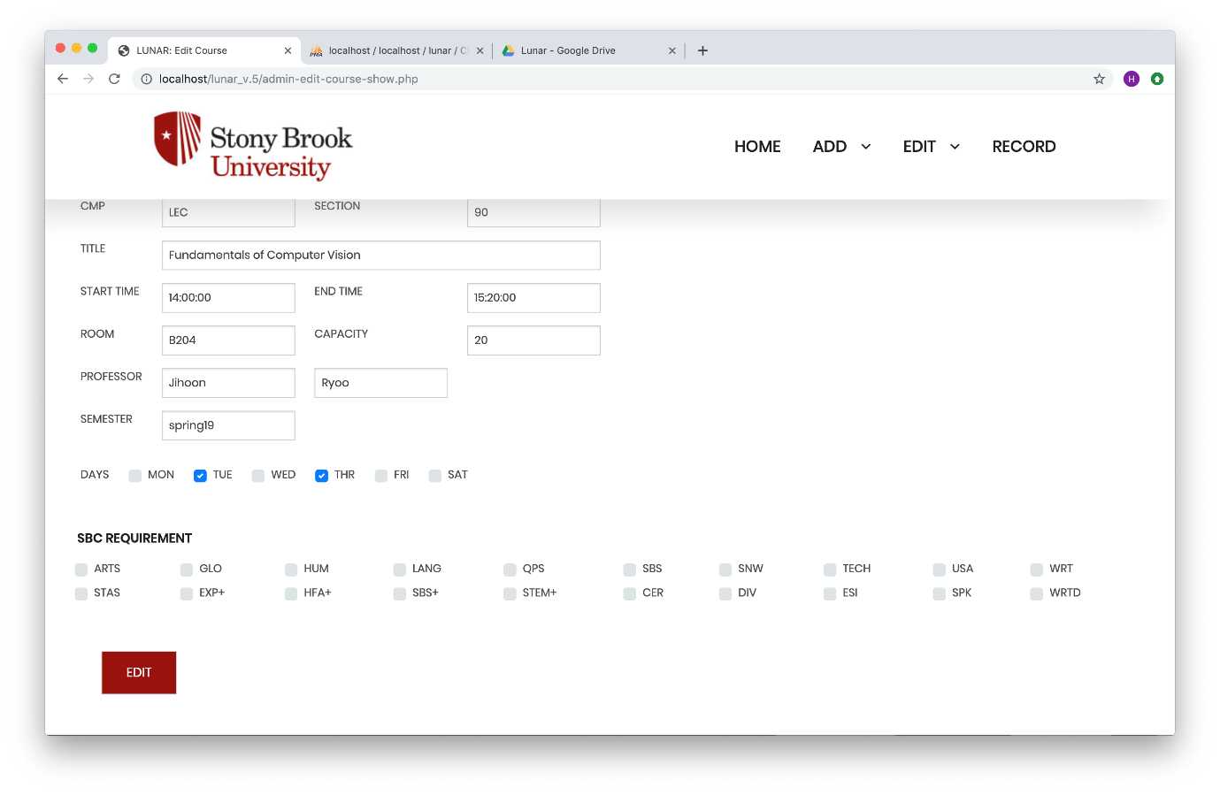

Figure 17. Edit A Course Example

Admin can also click this button to edit the desired student by entering the ID number of the student (Figure 18). Admin can edit a student by giving a student ID, first name, last name, major, and minor. Figure 19 shows an example of editing a student.

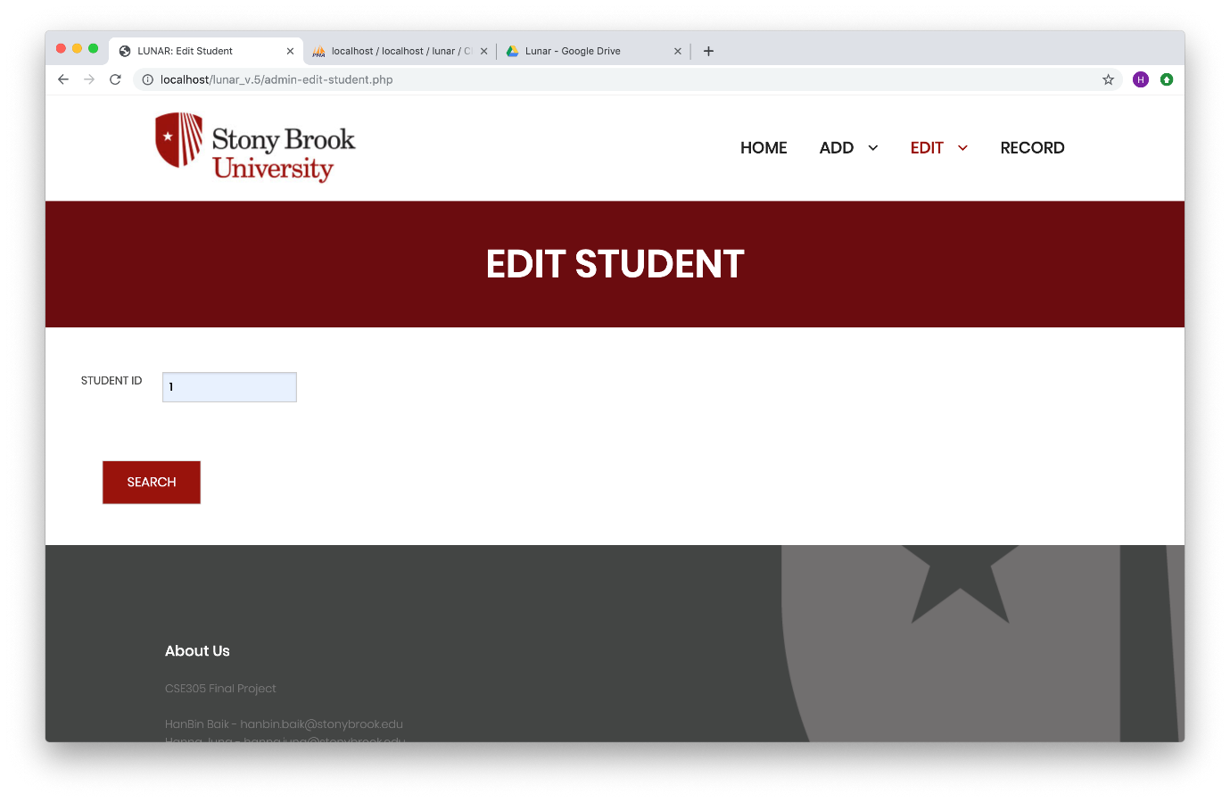

Figure 18. Enter A Student ID Number to Edit Student

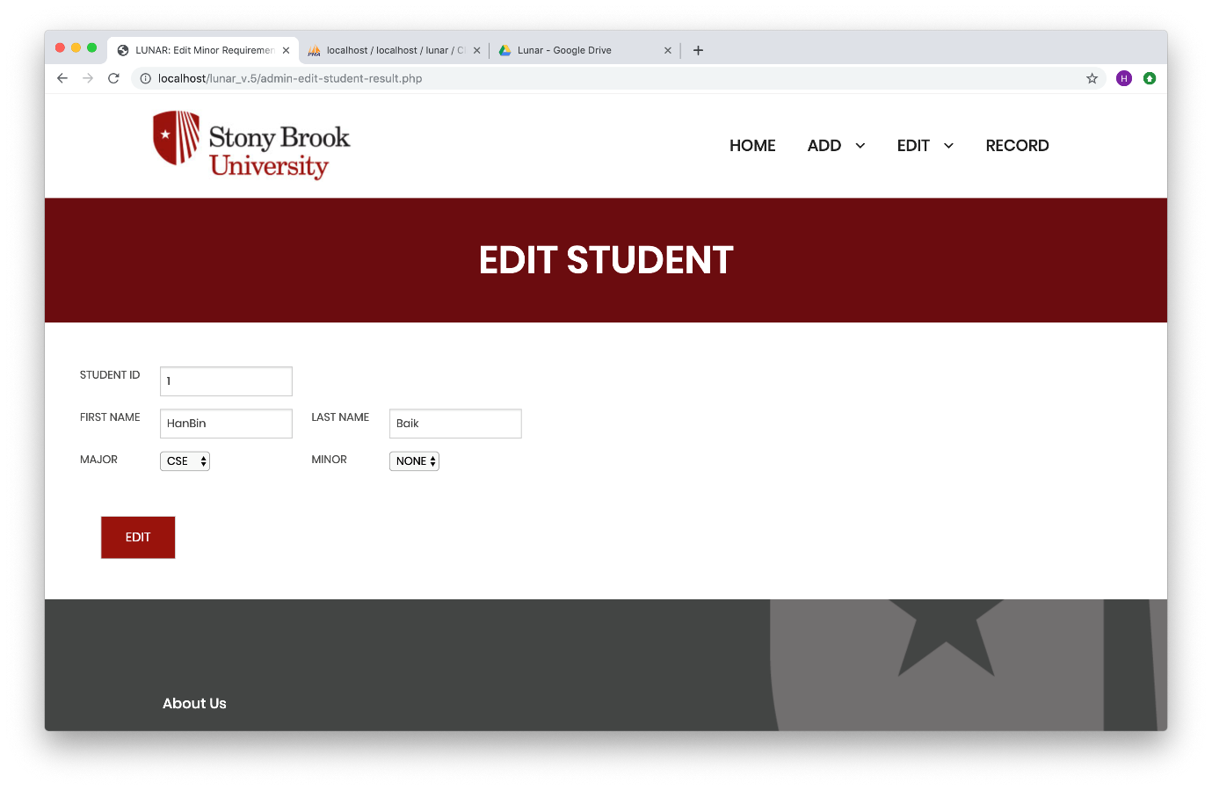

Figure 19. Edit A Student Example

**3.2.4 Record Button for Admin**

Admin can enter student id to view a student’s record (Figure 20). It shows a student’s history record (Figure 21). In this example, this student did not take any other classes before spring 2019 (current semester). So, the GPA is 0 in this case.

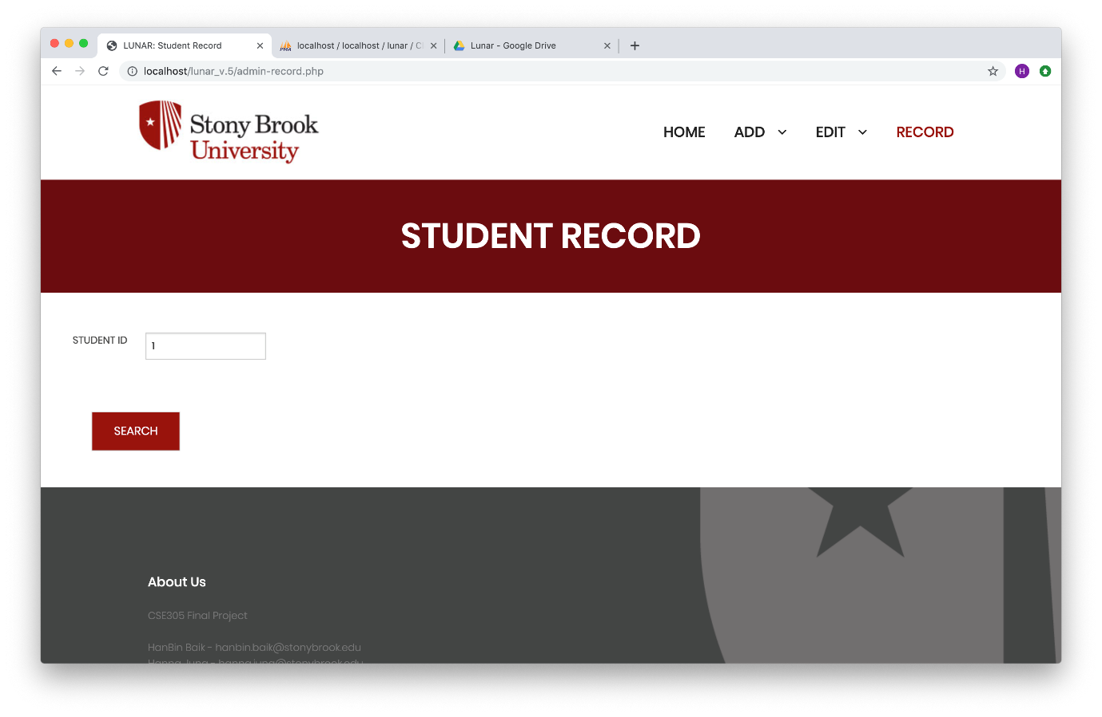

Figure 20. Typing a Student ID to View A Student ID 1’s Record

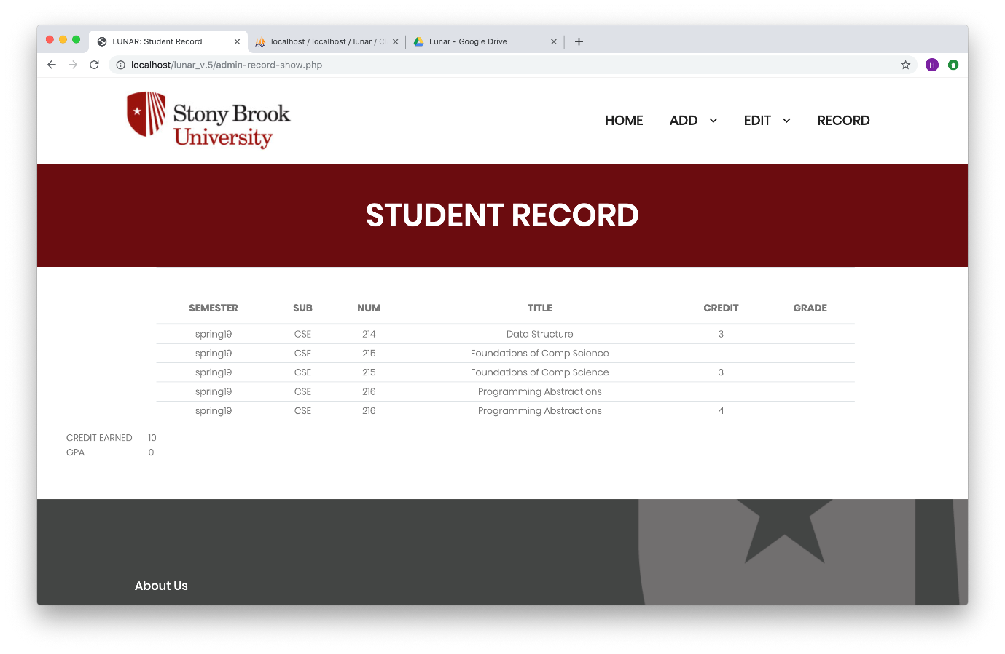Figure 21. Student Record Page

**3.2.5 Search Button**

A student must decide which semester he or she will find before he or she finds a class (Figure 22). Then a student can click search condition by giving a course id, subject, course number, professor, and SBC requirement. A student does not need to fill all the information about the course. Figure 23 shows how to search a class only by giving a subject name and a course number. Figure 25 shows how to search a class by giving not only the subject name and a course number but also the SBC requirements. Only the courses with satisfied condition will come out as a result (Figure 24 and Figure 26).

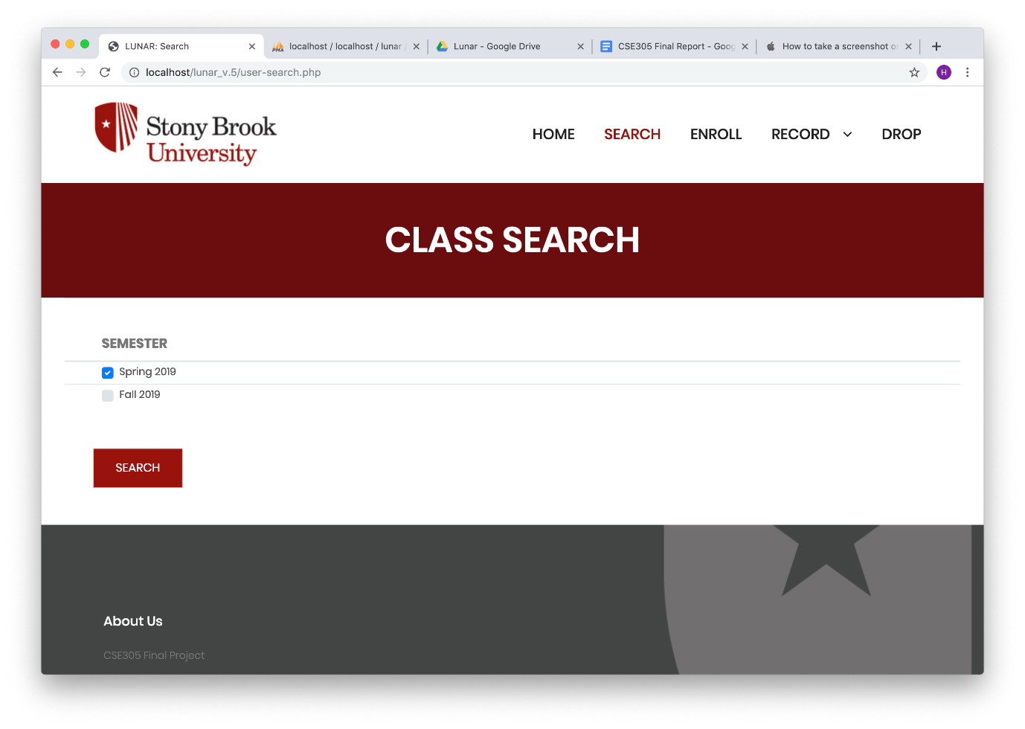

Figure 22. Class Search Page to Choose A Semester

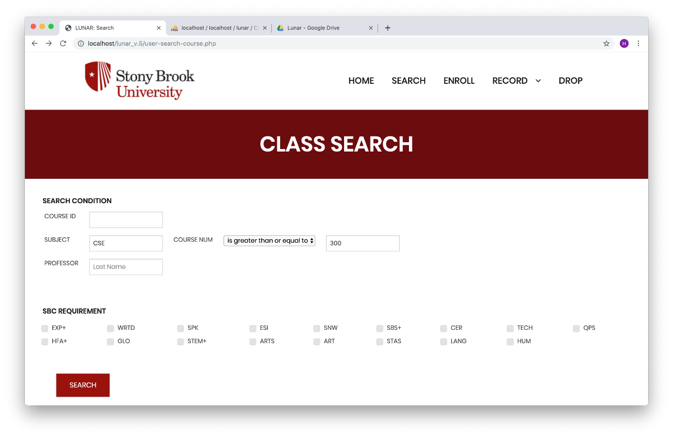

Figure 23. Class Search Page with Some Conditions (1)

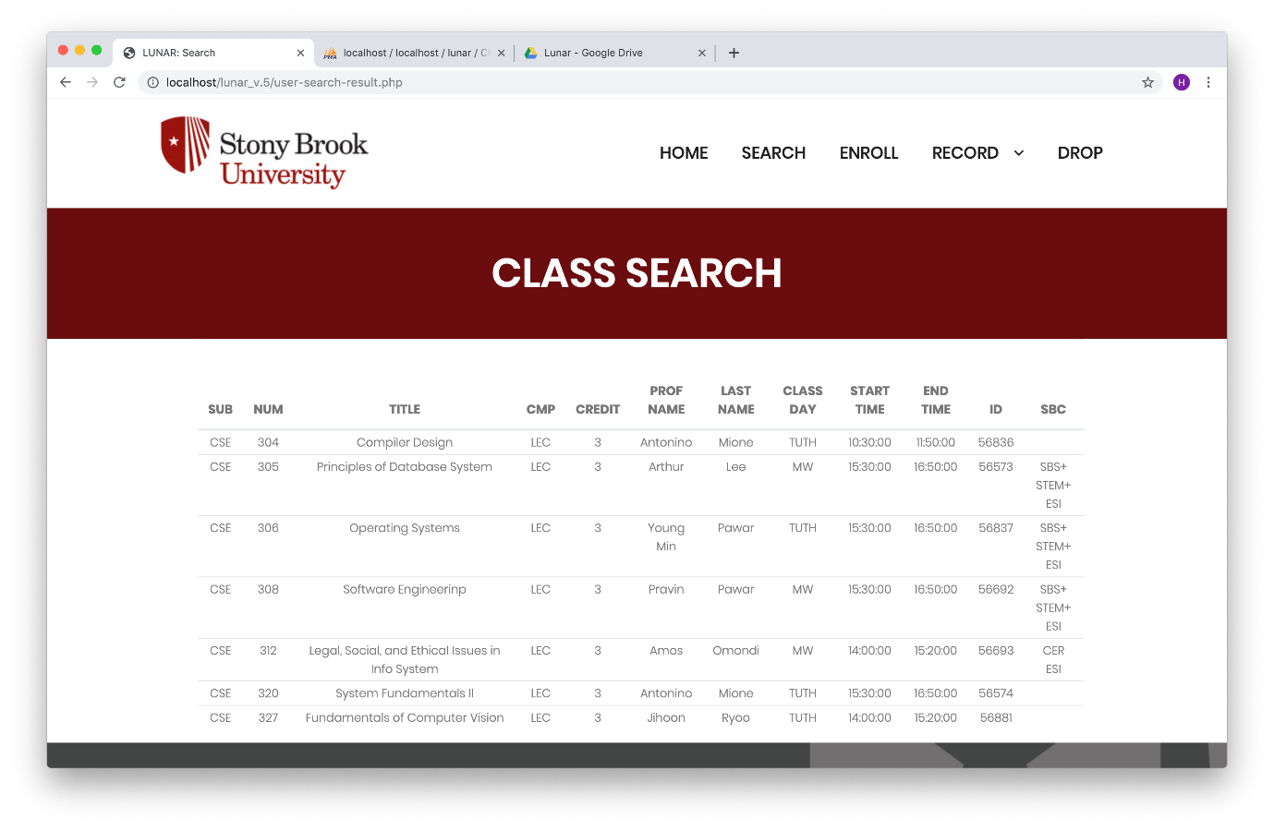

Figure 24. Class Search Result Page (1)

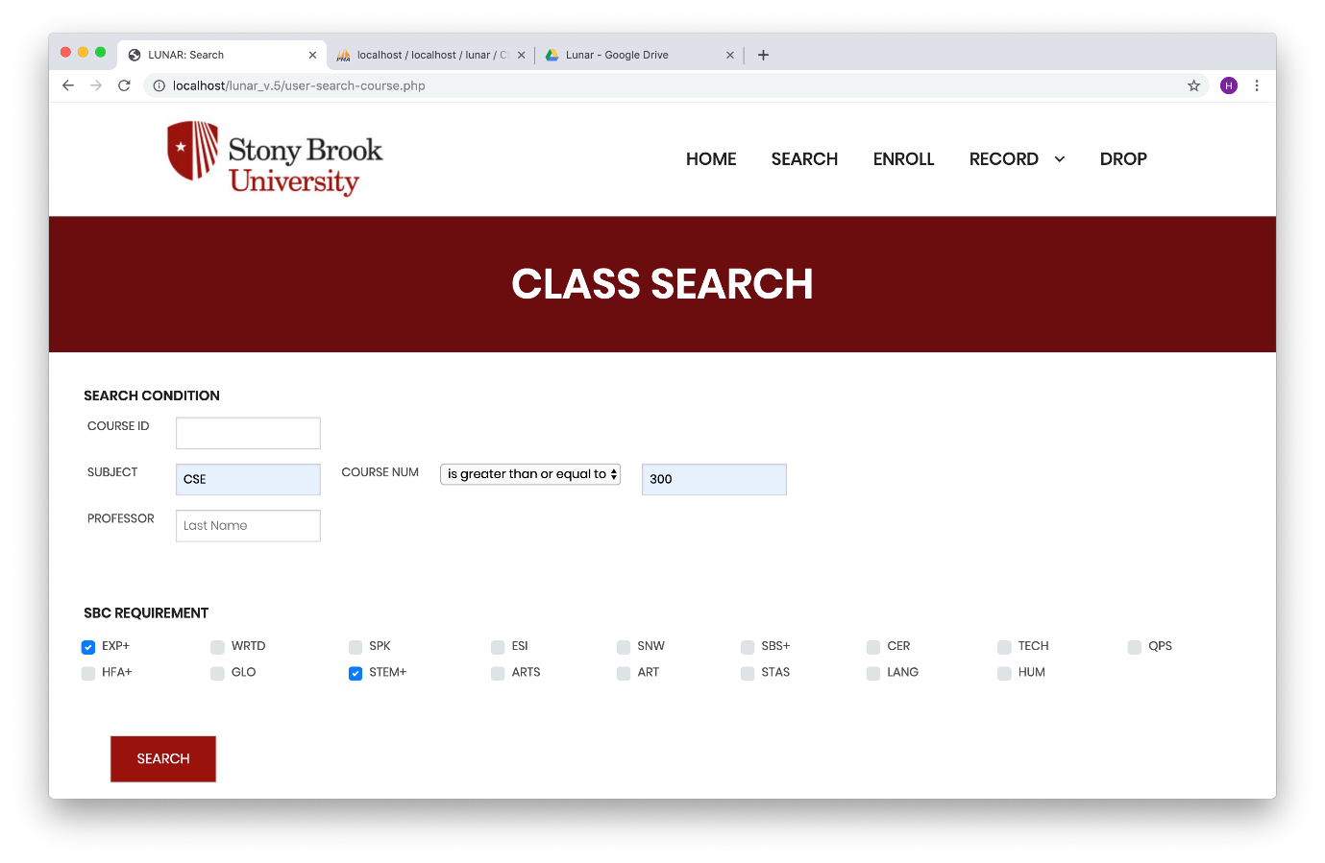

Figure 25. Class Search Page with Some Conditions (2)

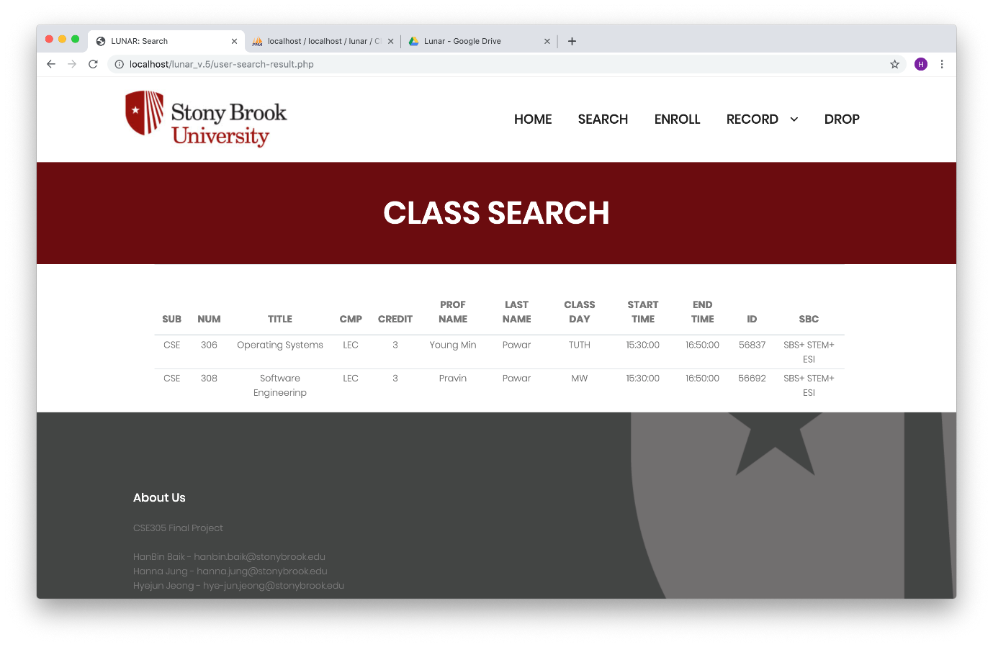

Figure 26. Class Search Result Page (2)

**3.2.6 Enroll Button**

A student can enroll a course by giving course id number (Figure 27). Then the page shows all of the enrolled courses (Figure 28).

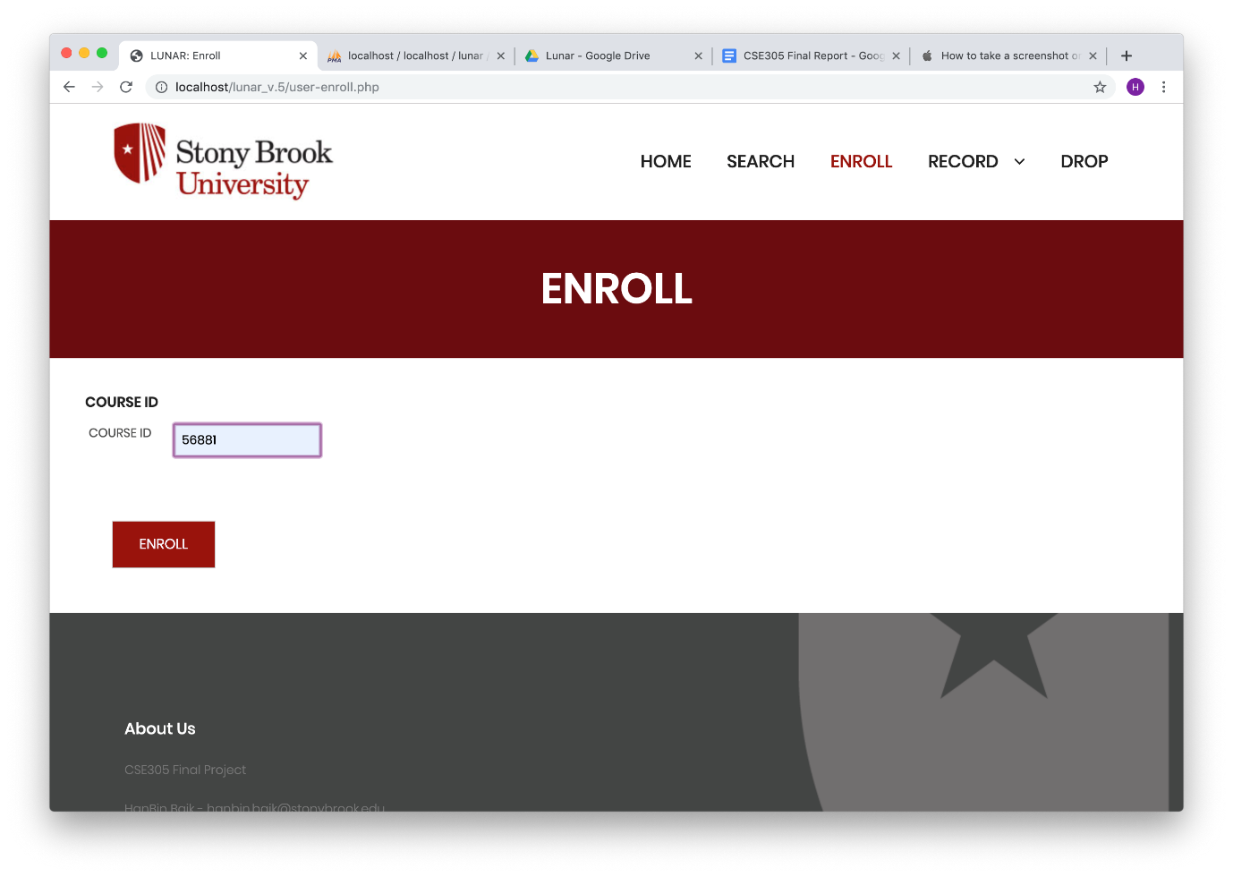

Figure 27. Enroll a Course with Course ID

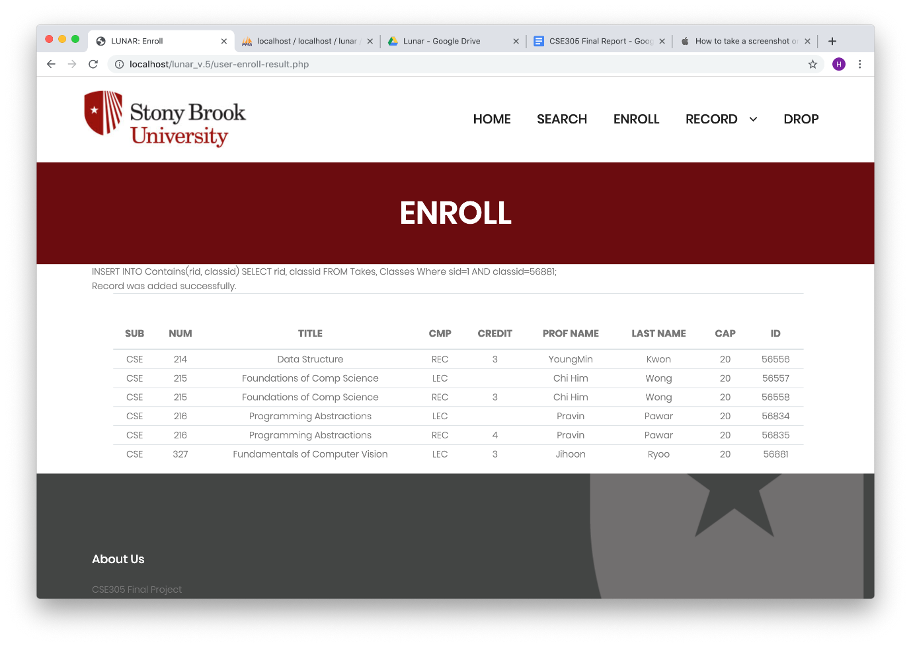

Figure 28. Enrolled Courses Page

**3.2.7 Record Button for Students**

A student can click this button to view his/her current and history record. On the current record page, it shows the courses that student is taking with semester, subject, subject number, title, credit, and applied credits (Figure 29). If a student takes a zero-credit course, it shows null value.

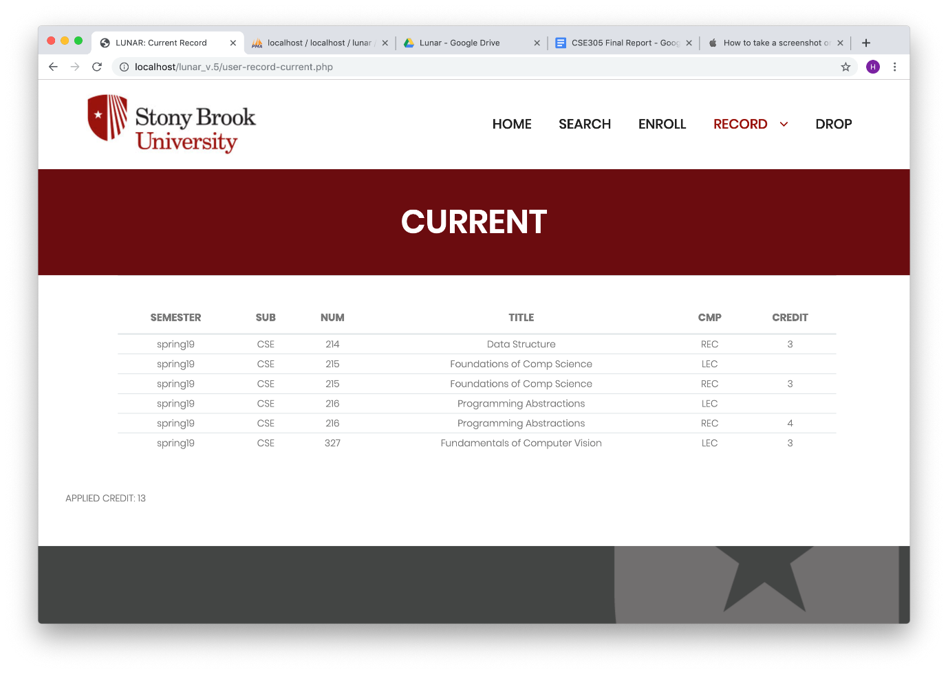

Figure 29. Current Record Page

On the history record page, it shows the courses that student is taking and have taken so far with semester, subject, subject number, title, credit, grade, credit earned, and GPA (Figure 30). In this example, this student did not take any other classes before spring 2019 (current semester). So, the GPA is 0 in this case.

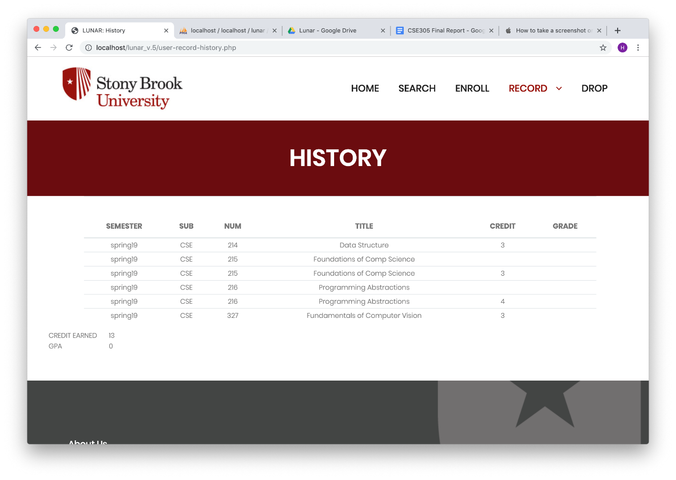

Figure 30. History Record Page

**3.2.8 Drop Button**

A student can click this button to drop courses. A student must decide which semester he or she will find before he or she drops a class (Figure 31). Then, the page shows all the courses with check box at the left most column of that semester. A student can check the check box of a course and click drop to drop that course (Figure 32). The page shows all the courses without a dropped course. Figure 16 shows all the courses without a dropped course, which is CSE 327 (Figure 33).

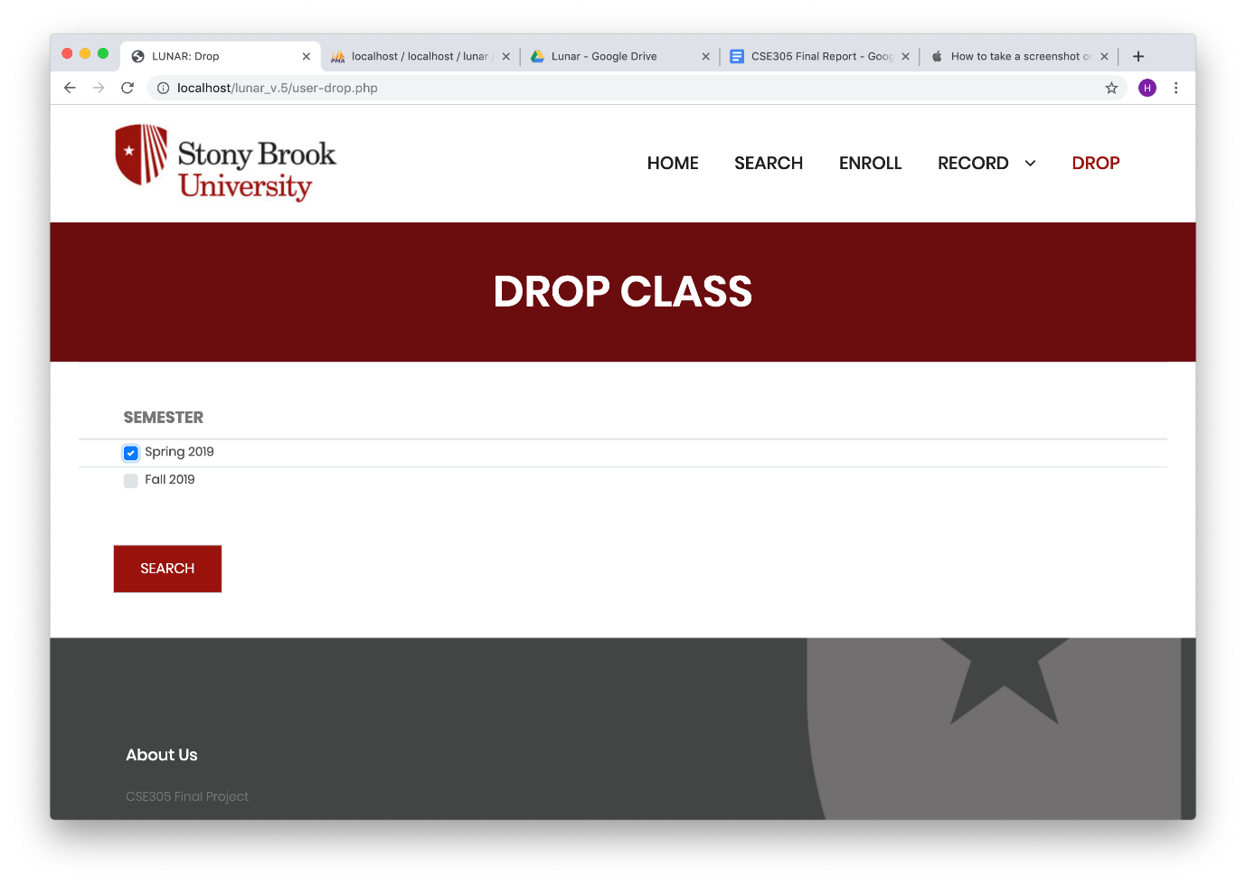

Figure 31. Drop Course Page to Choose A Semester

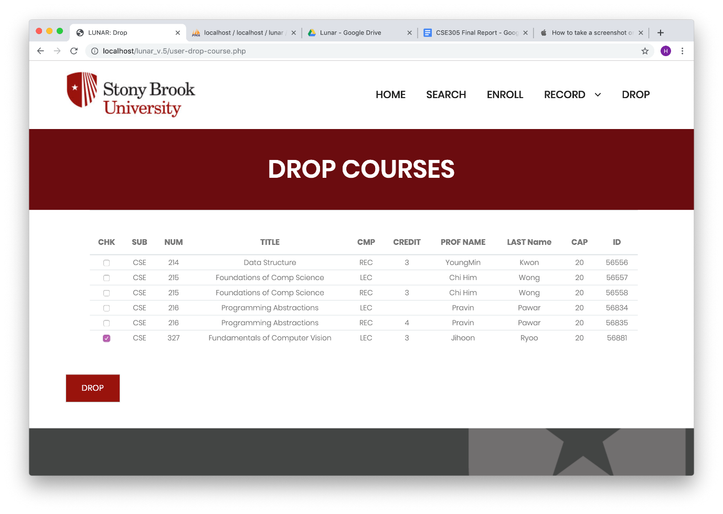

Figure 32. Select A Course to Drop

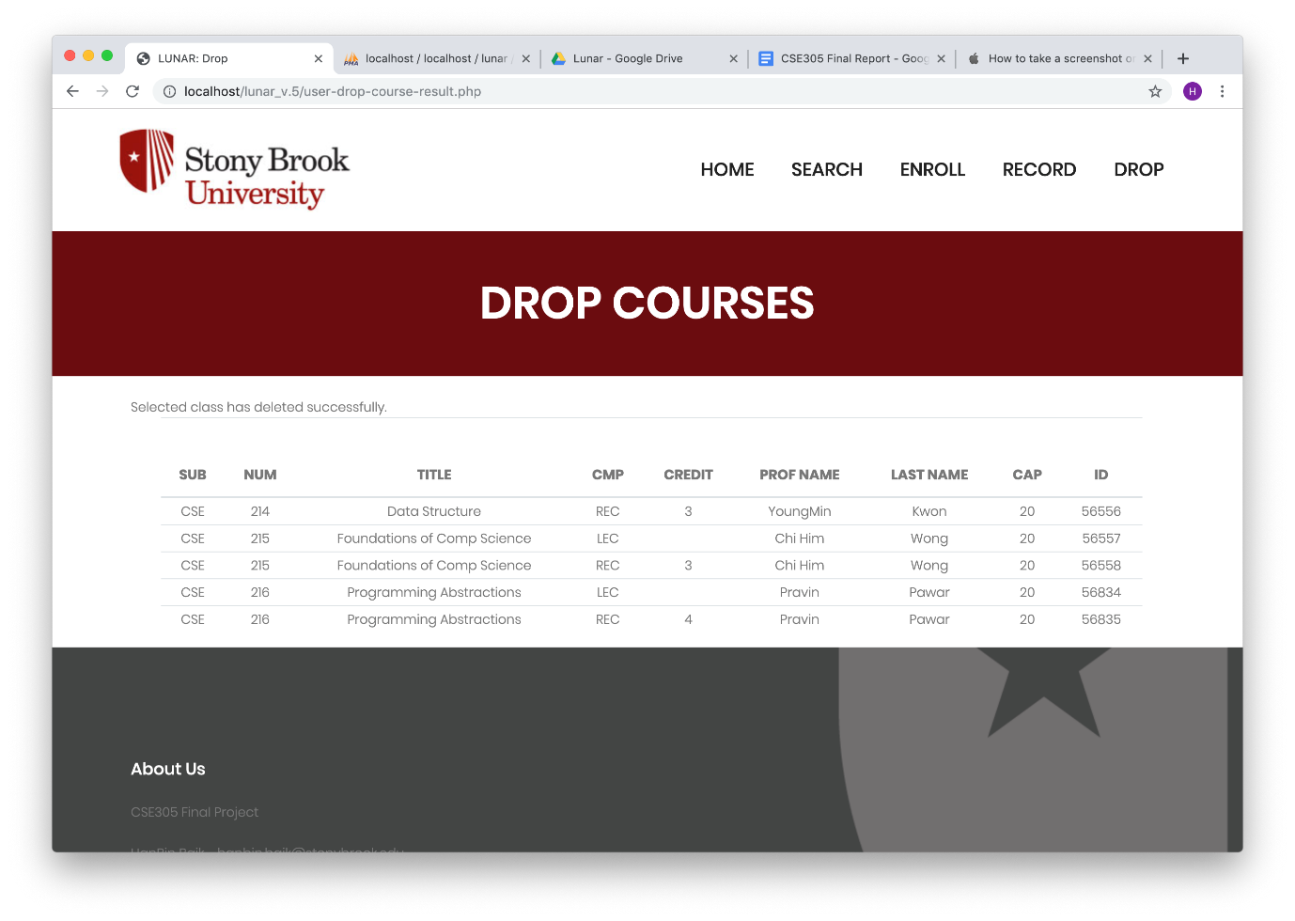

Figure 33. Courses Lists After Dropping A Course